Clarifications of this project: To find out which employees are due for a pension increase, the program takes an excel sheet of employees and spits out output of who is due for an increase and etc.

Program workbook: Button is pressed and then a prompt will ask for employee data file

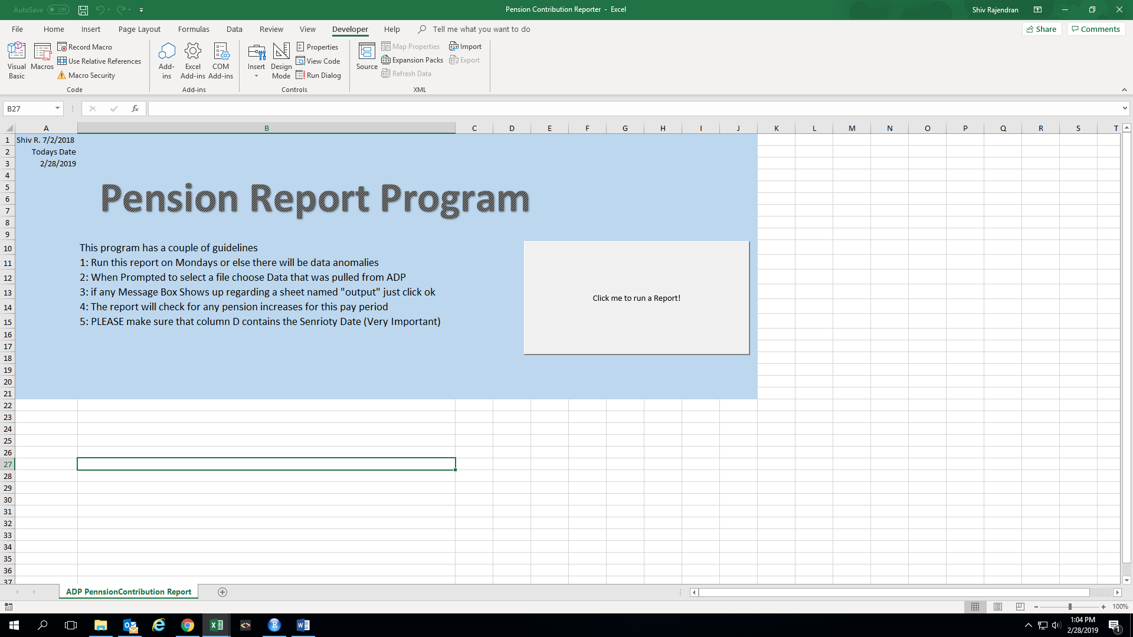

Button prompts u to select a file

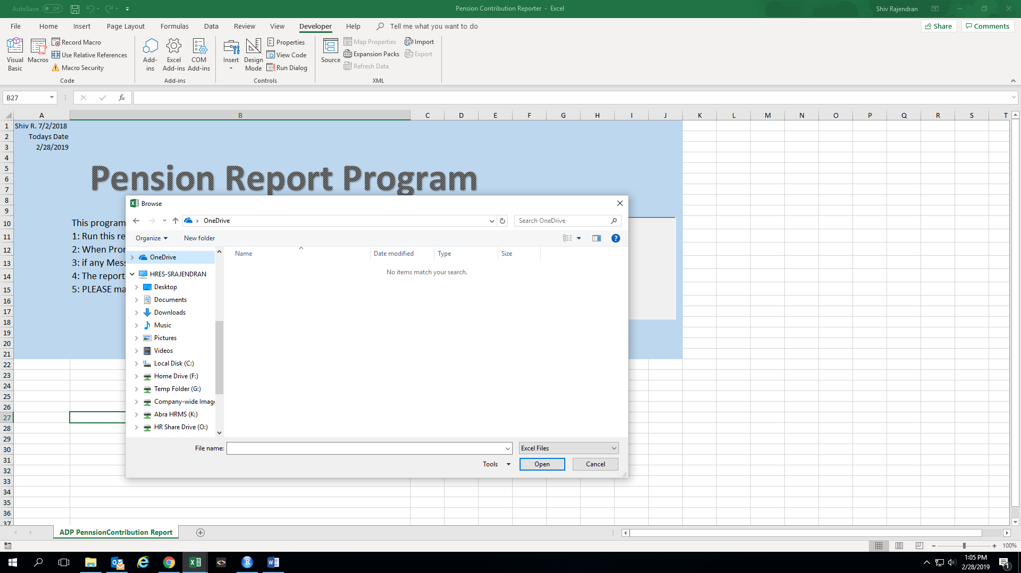

After File is selected: spits an output file by running macro

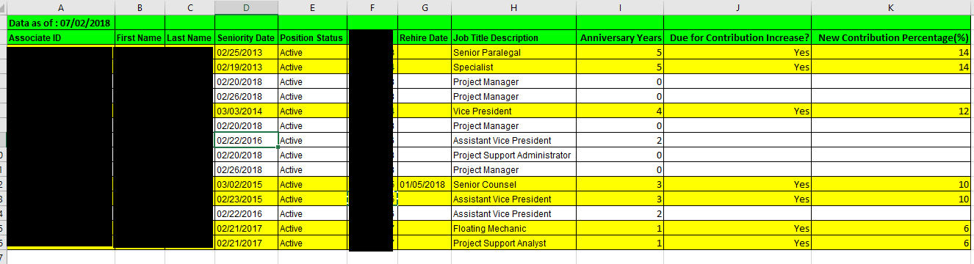

Macro also can be run at any time as long as input data is set up properly.